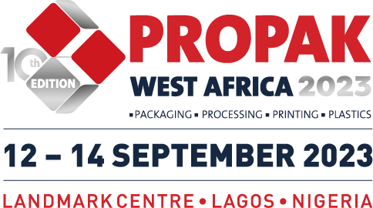
Propak West Africa 2023 Post Show Press Statement
This month, Propak West Africa returned to Lagos, Nigeria for its highly anticipated 10th Edition, welcoming 4,931 industry stakeholders through the doors to visit 152 exhibitor stands, showcasing the newest innovations from over 200 brands along with exciting live demonstrations of the latest equipment in action on the exhibition floor.
This year’s edition, marking 10 years of Propak took place from 12 – 14 September 2023, saw industry professionals from across the packaging, plastics, printing and food processing industries unite under one roof to source the latest products and solutions to take their supply chain to the next level. This year’s event was opened by welcome remarks from Marilyn Obaisa-Osula, Associate Director, ESG/Sustainability at KPMG in Nigeria, Aruna Oshiokamele, Managing Director at Tetra Pak West Africa and Segun Ajayi-Kadir, Director General at Manufacturers Association of Nigeria (MAN) alongside an official introduction and address from George Pearson, Regional Director of Afrocet Montgomery.
The exhibition halls were packed out with brands from all corners of the globe represented, international exhibitors included: Alps Machine, Coperion, Dura Impex, Galaxy Sivtek, Hilda Automation, Illinois Enterprises Co., Miele, Neofyton, Reifenhäuser, Serac, Stavian and Transworld Multipurpose Industries to name just a few. Organisers were also thrilled to receive much support from the local market with many leading suppliers present including ADECO, Beaumont Industrial Services, Boustani & Partners, CIS Buro, Esspak, Integrated Power Technologies Ltd, Mercongraphic, Msquare and Scube, Newlord Nigeria, Pacegate, Samtech, Tekniteed and Volpak.
Onsite, at this year’s special edition of Propak West Africa, George Pearson said “As organisers we are thrilled Propak West Africa has reached the 10-year milestone. Since its launch, Propak West Africa has firmly established its status as the leading platform for local and international suppliers to meet, network, and do business with the biggest names in manufacturing in the West African region. From its humble beginnings back in 2012, the exhibition has seen the overall size increase by over 300%, a testament to how Propak West Africa continues to be an influential and effective platform for both companies looking to establish and develop their footprints in the region”
Once again, the high-level conference programme returned to Propak this year with Organisers thrilled to have partnered with KPMG Nigeria as well as Institute of Packaging Nigeria in assembling a 2-day conference agenda which saw an esteemed line-up of speakers take the stage to share their expert knowledge and insight on the future of packaging and key market trends to watch out for in a series of presentations and panel discussions.
Propak West Africa 2023 certainly proved to be an unforgettable event, with such a positive reception from the industries in the region attendees and exhibitors alike were overwhelmingly pleased with the event. Organisers were thrilled to have been able to celebrate a decade of Propak with such a successful event demonstrating the platform’s retained importance for the manufacturing sectors in West Africa.
This year’s exhibition saw a fantastic onsite rebooking of 65% of the exhibition floorspace sold, which is an excellent indicator for exhibitor's expectations of continued success at Propak West Africa’s return in 2024 on 10 – 12 September. Organisers are looking forward to welcoming back the industries next year, with the event well on course for further growth.
For further information on next year’s event and where your company could fit in, do visit the website or get in touch today.
www.propakwestafrica.com
Tsitsi Musumhi
Tsitsi.Musumhi@montgomerygroup.com
+44 207 886 3032

